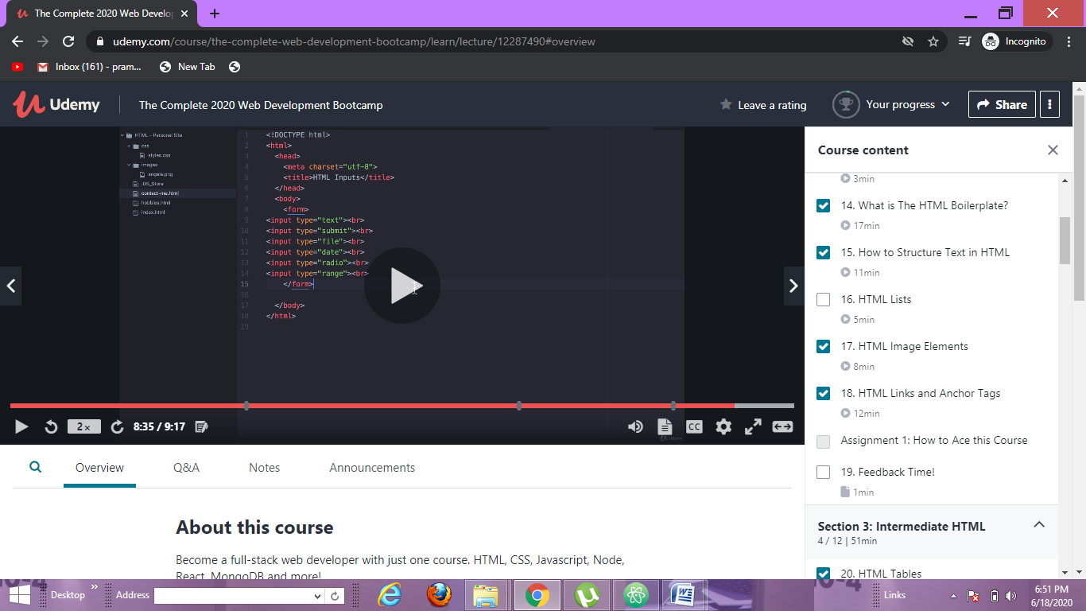ALL THE INPUTS TRIED

